**Hardware and Software Requirements to Install MySQL**

* **Operating System**: Windows 10, 8, 7, or Windows Server 2016/2019.
* **Hardware**: At least 4 GB of RAM and 2 GB of free disk space (preferably more for optimal performance).
* **Software**: Windows must be up-to-date. Make sure to uninstall any older versions of MySQL to avoid conflicts.
* **Network**: An active internet connection to download the MySQL installer.

**Download and Install MySQL for Windows Steps**

Now, Let's break down MySQL software downloading steps for a better understanding and see install MySQL on Windows 10 step by step.

**Step 1: Visit the Official MySQL Website**

Open your preferred web browser and navigate to the official MySQL website.

[MySQL :: Download MySQL Installer](https://dev.mysql.com/downloads/installer/)

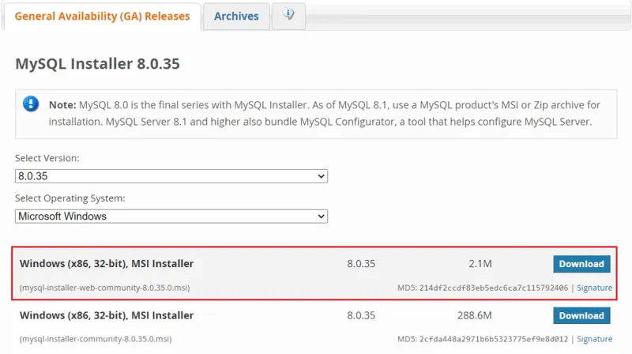

**tep 2: Go to the Downloads Section**

On the MySQL homepage, Click on the " **No thanks, just start my download**" link to proceed MySql downloading.

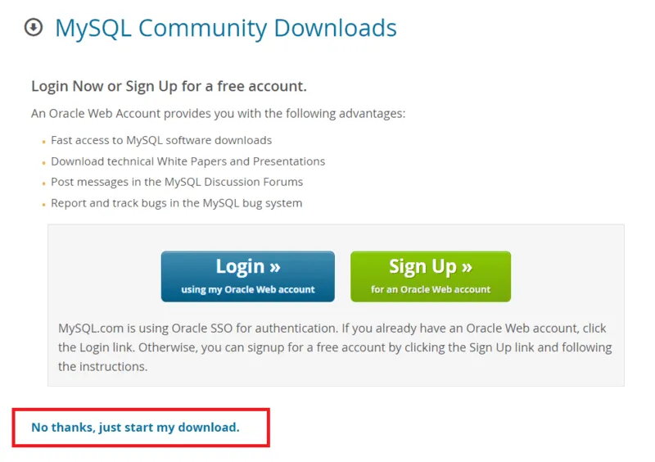

**Step 3: Run the Installer**

After MySQL downloading**MySQL.exe** file , go to your Downloads folder, find the file, and double-click to run the installer.

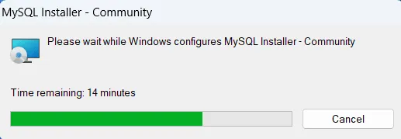

**Step 4: Choose Setup Type**

The installer will instruct you to choose the setup type. For most users, the "**Developer Defaul**t" is suitable. Click "Next" to proceed.

**Step 5: Check Requirements**

You might be prompted to install necessary MySQL software, typically **Visual Code**. The installer can auto-resolve some issues, but not in this case.

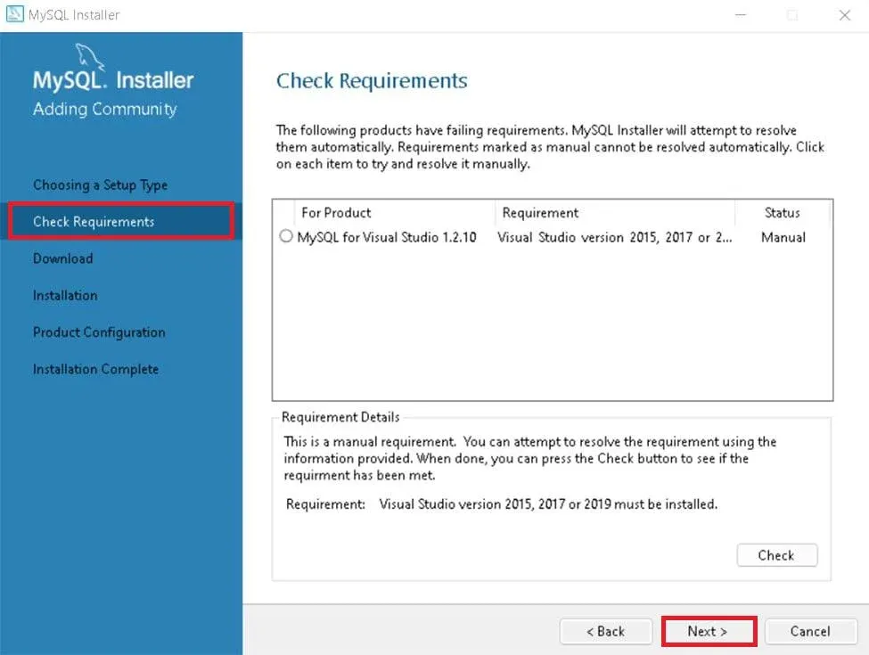

**Step 7: MySqL Installation**

Now the downloaded components will be installed. Click "**Execute**" to start the installation process. MySQL will be installed on your Windows system. Then click **Next**to proceed

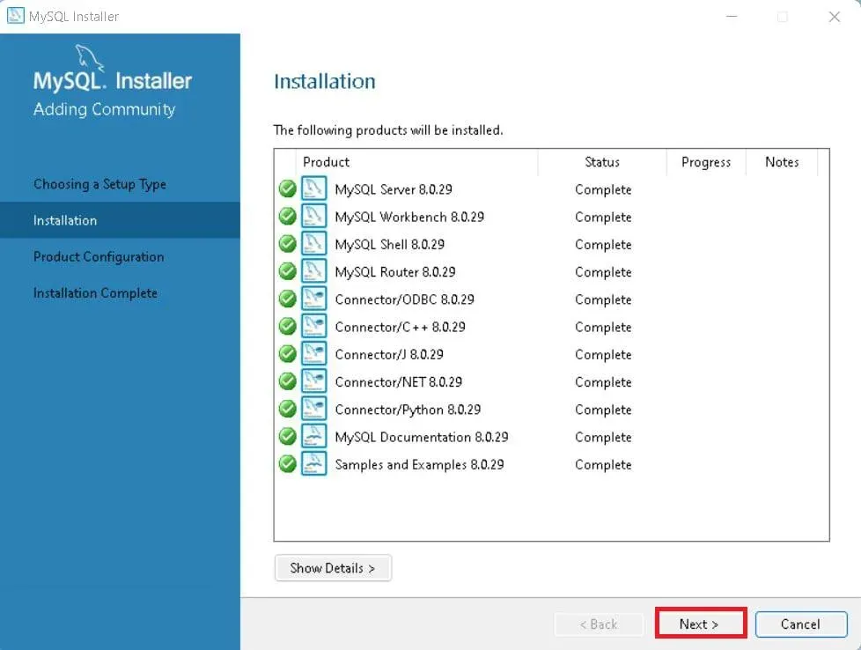

**Step 8: Navigate to Few Configuration Pages**

Proceed to "**Product Configuration**" > "**Type and Networking**" > "**Authentication Method**" Pages by clicking the "Next" button.

**Step 9: Create MySQL Accounts**

Create a password for the MySQL root user. Ensure it's strong and memorable. Click "**Next**" to proceed.

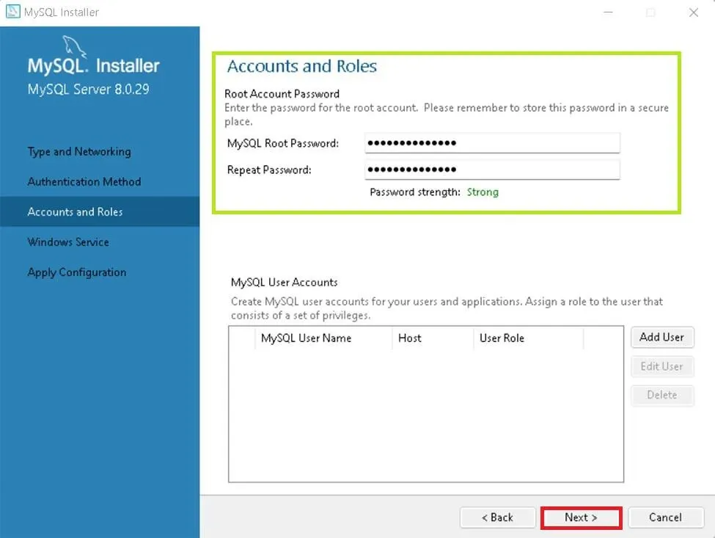

**Step 10: Connect To Server**

Enter the root password, click Check. If it says "**Connection succeed,**" you have successfully connected to the server.

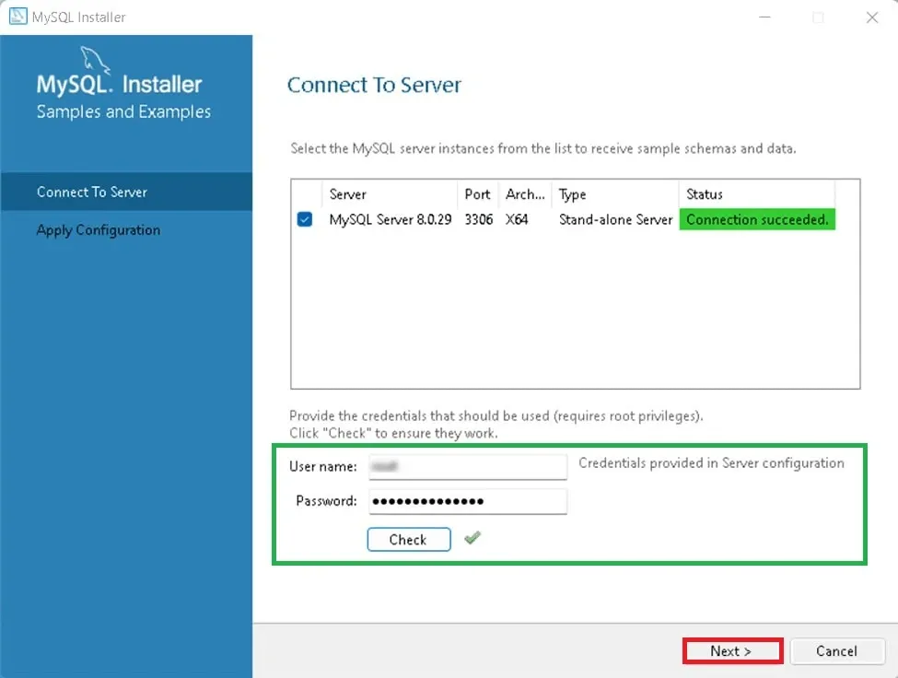

**Step 12: Verify Installation**

To ensure a successful installation of MySQL, open the MySQL Command Line Client or MySQL Workbench, both available in your Start Menu. Log in using the root user credentials you set during installation.

**MySQL Workbench Is Ready To Use**

MySQL is an open-source relational database management system that is based on SQL queries. MySQL is used for data operations like querying, filtering, sorting, grouping, modifying, and joining the tables present in the database.

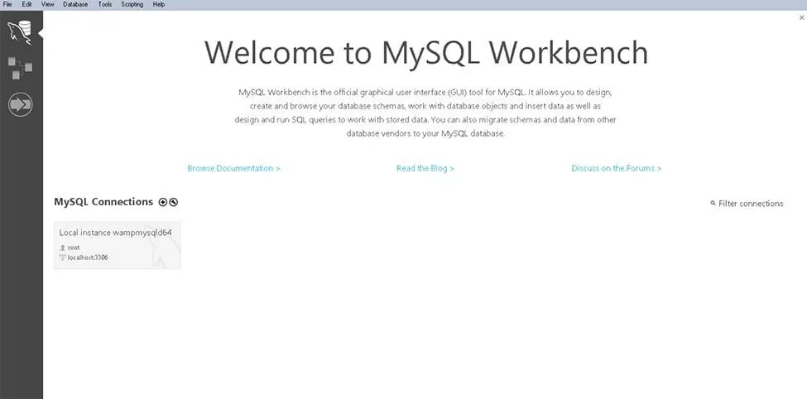

**Troubleshooting Common MySQL Installation Issues**

If you encounter any issues during the MySQL installation process, here are a few common solutions:

1. **Error-Port 3306 is Already in Use**: MySQL uses port **3306** by default. If another application is using this port, change the port number during the configuration step.
2. **MySQL Service Fails to Start**: Ensure that your Windows firewall is not blocking the MySQL service. Check the Windows Services and verify that the MySQL Serve**r** is running.